INCREMENT-4

SWINNEY-GENNIE

Project: Our project is Swinney-Gennie which is related to our UMKC swinney. Whenever we go to swinney for playing they will be out of courts or items for playing. We just got idea of this project by this. This project is nothing but when a student logins with his id and password he will get the screen of available items and no of places available in a court. Now he can easily go to swinney whenever the items and courts are available. We have also developed admin side for checking out and checking in what all the items the student has taken.

Working of our project:

1) This is our home page:

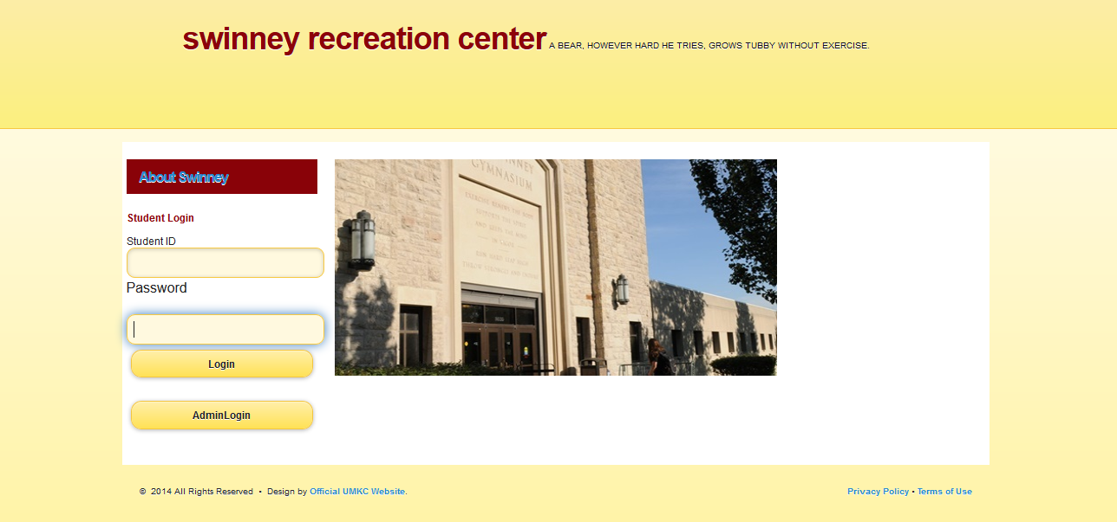

2) When the student logs in with the student details like this 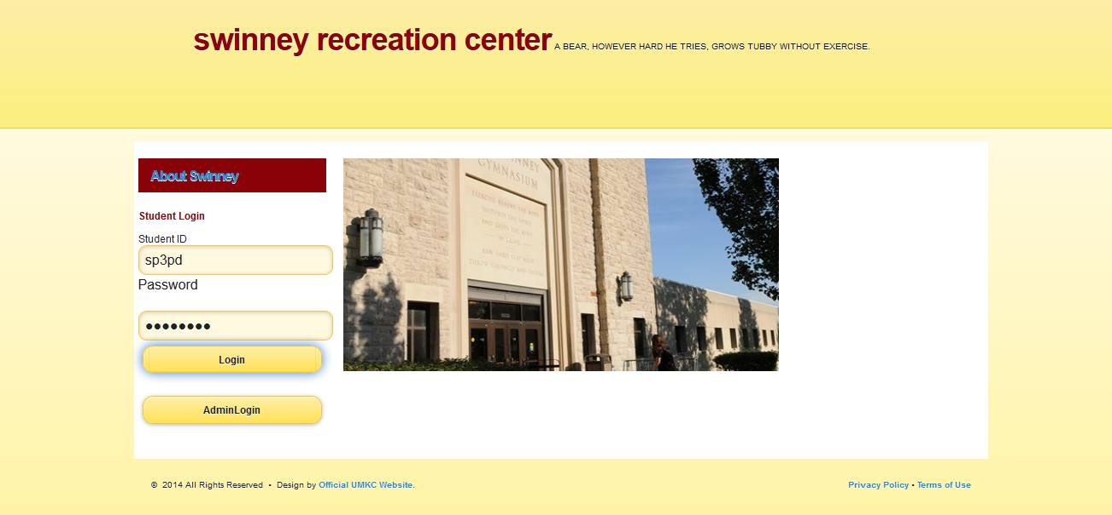

We will get the following page:

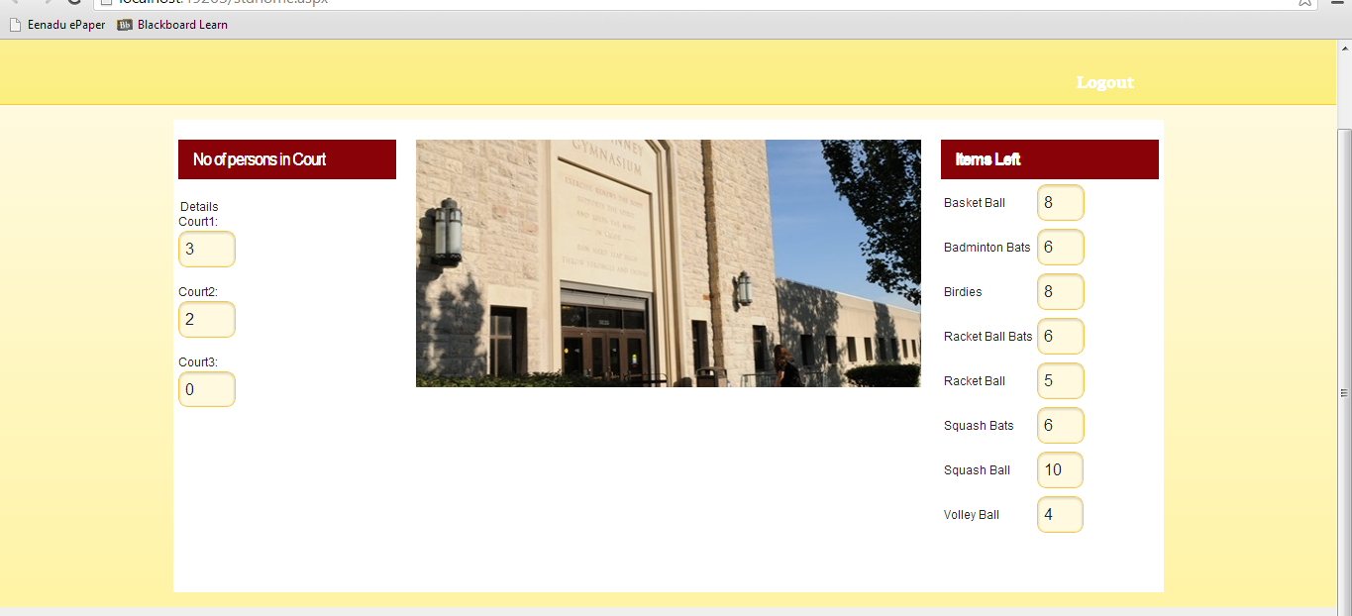

He will get a page where he can see the list of available items. Here we will also get no of persons in the court ie; total no of persons registered for court. Four persons have to be in a court, so the student can see the availability of the court too. If the court is full he will get an email notification when the court becomes free to the college mail from the admin. The below is the screenshot for that.

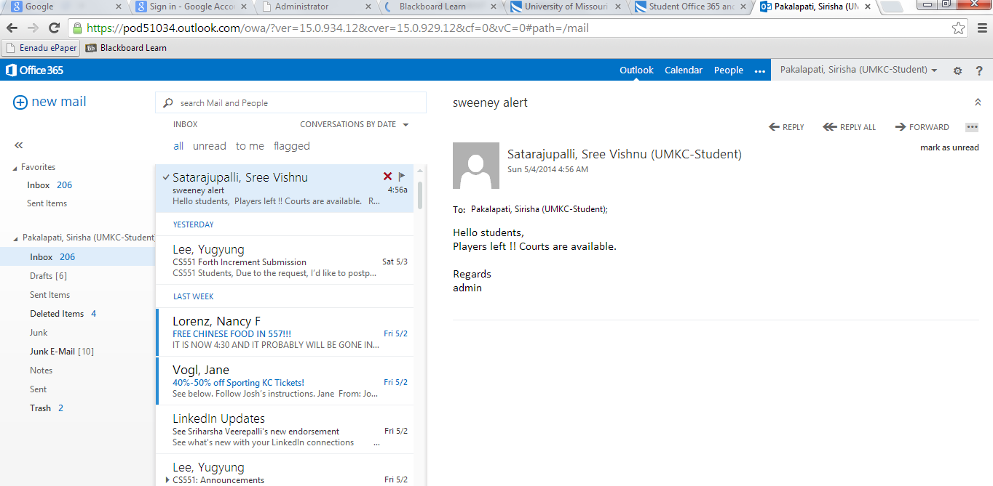

On seeing the available items he will go to swinney and tell the assistant what all the items he wants. Now the Admin (ie; the person at the desk of swinney) will click on the admin login in the home page.

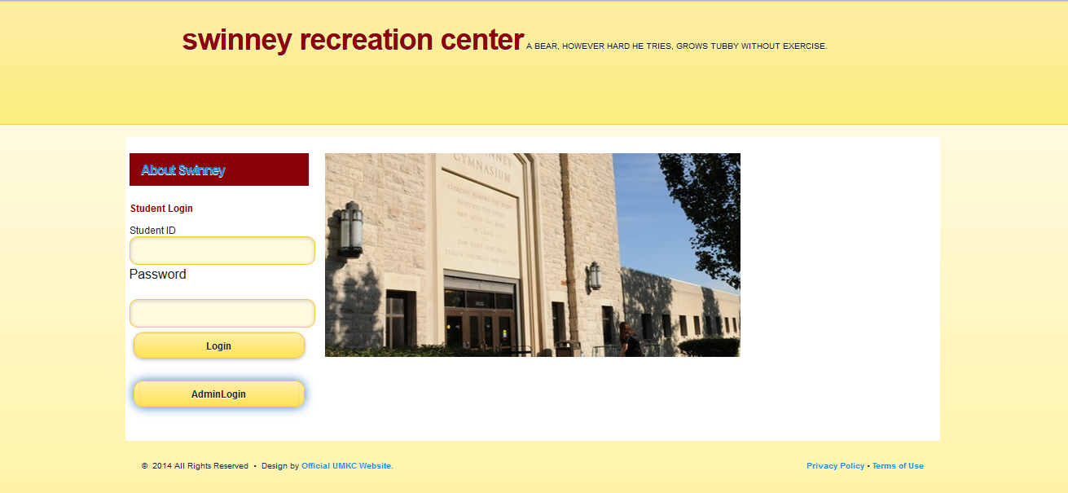

Now he will get this page where he can see the available list and he can enter the details of the student:

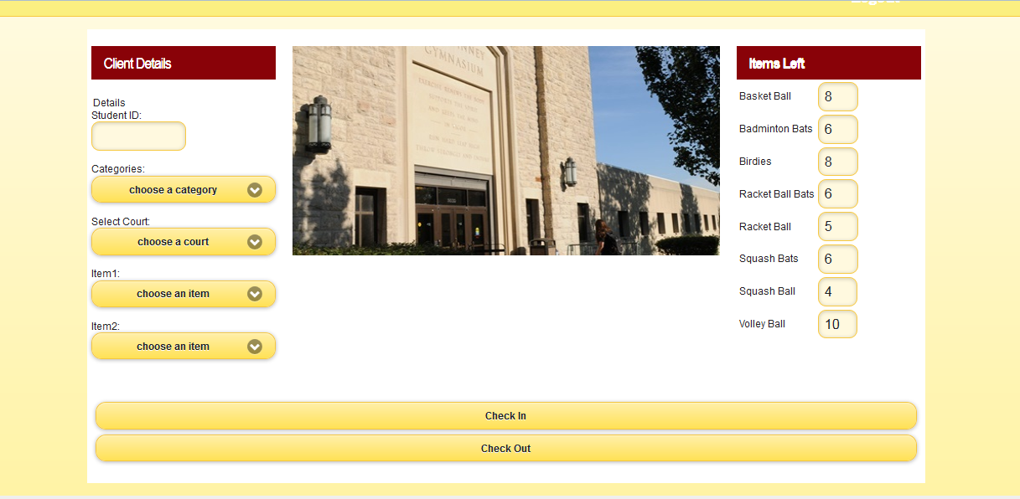

Now the admin enters the details of the student and then he checks in

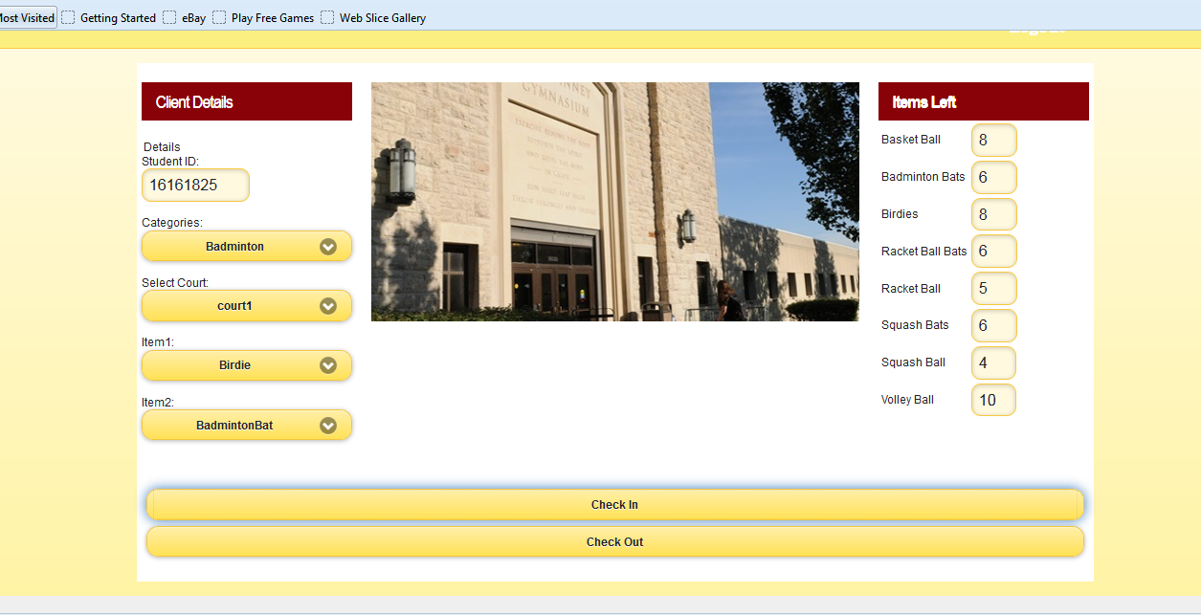

After he checks in then he will get the following screen:

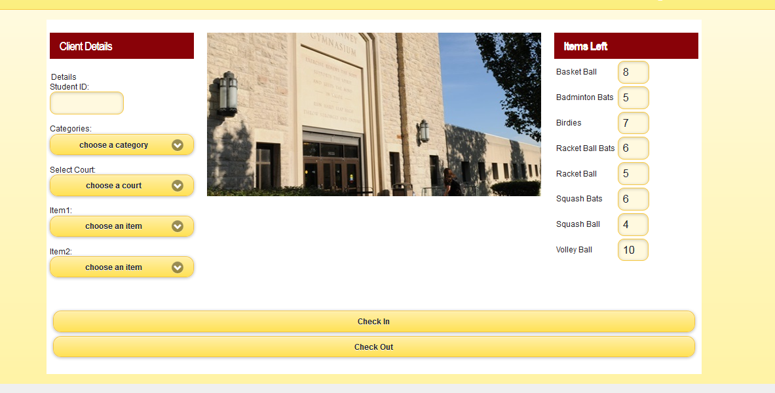

When the student comes for the checkout, the admin enters the particular student id of that student and then he clicks checkout.

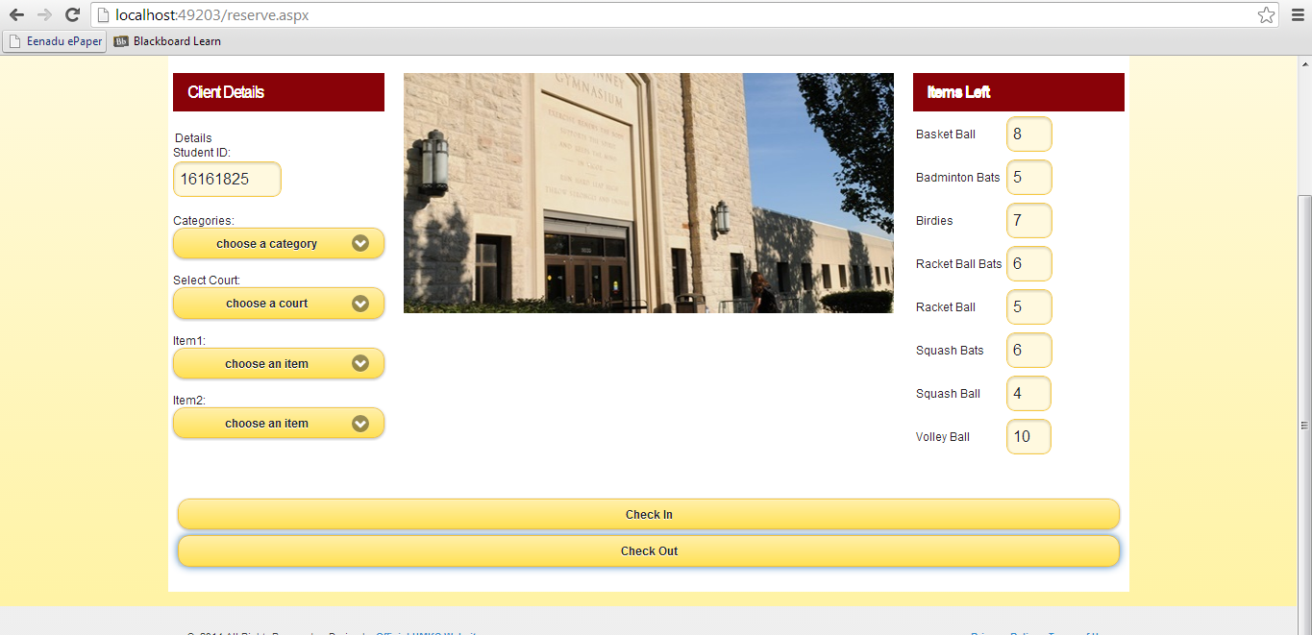

Now he will get the following screen by checking out all the items taken by that particular id of that student.

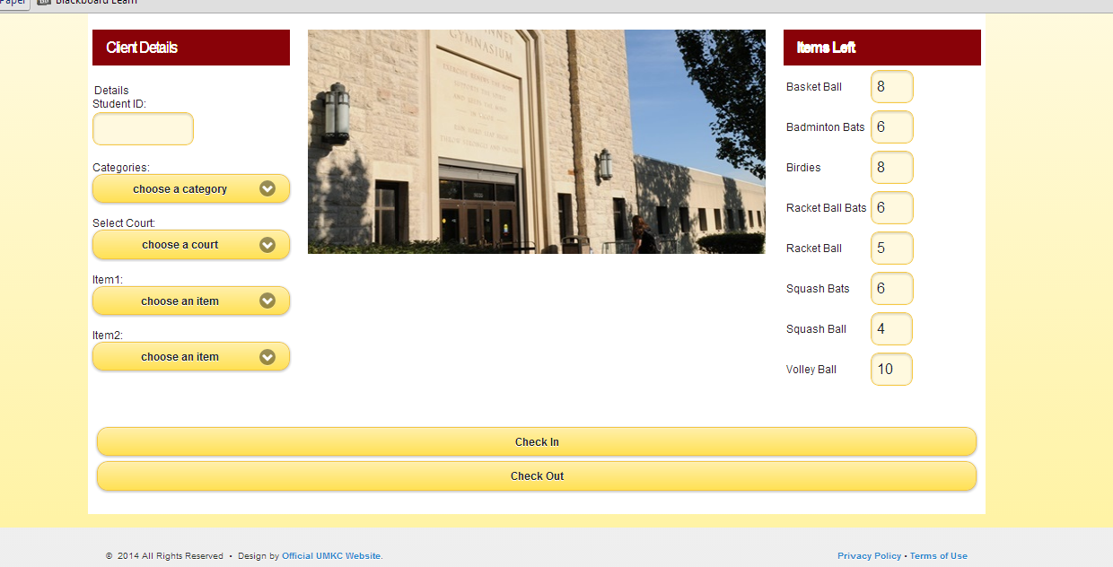

When the student or Admin logs out he will get the following screen ie: home page:



This is the scrum do link of our project:

<https://www.scrumdo.com/organization/ase6/dashboard>